6/11/2019 A letter to anyone, and especially those on +Daniel’s list
On the 2nd anniversary of +Daniel’s death (+2017, Sunday of All Saints)
Tomorrow (06/11/2019) is the second anniversary of my son +Daniel’s repose. He was not yet 21 when he jumped into a cold river in Berlin, to swim across it with a friend, as a kind of a lark. He and his friend looked at each other before they jumped in and said “here’s to being young”. Now +Daniel is, I guess, forever young. In Berlin it was the Sunday of All Saints at 6 AM, and about 10 o’clock Saturday night in McKinney Texas. We have no idea that he had reposed until Monday morning. The US Embassy didn’t have a correct number for us, and finally got in contact with us more than 24 hours after he reposed.
I wrote a letter about +Daniel’s repose on the anniversary, and I thought I would try to keep up the tradition. We’ll see how many years it goes. I was thinking about what to write, and a phrase came to mind that people sometimes say when someone dies: “his untimely repose”. But I’m a Christian, and therefore his repose was not untimely. His repose was on the Sunday of All Saints, and on that particular Sunday, four icons of the mother of God were commemorated, and I’ve actually never thought that his repose was untimely. It was earlier than I wanted to be, but not untimely. Some of our language concerning death is unfortunate. Speaking of an “untimely repose” is one example. Do we believe in God or not? Do we believe in God’s providence over all of our life or not?
Two years of now passed since +Daniel’s timely repose, under the providence of God, and they have been very busy days. I made a bargain with God. I think it’s good to do such bargains, as long as they’re honest ones, and there’s no magic involved. God does not do magic. He does lead us in ways that we often cannot understand. He responds to our response to Him. He cooperates with our labor. Our labor is not strong enough to do anything, but most of the time, He waits for it before He does something.
My first response upon hearing about +Daniel’s death was to go to the church to pray. The first Panikhida I prayed completely alone. There would be 2 others that day. Almost immediately, I made my bargain with God. I’m in good company in doing such things. The prophet Moses did it, and it’s a monastic custom to do something extra when we want something from God. Those who are not Orthodox don’t understand this and consider this to be some sort of superstition, but we understand it to be merely being honest with God. How dare I ask Him to serve me without me being willing to serve Him! So, my bargain was that I would pray for people who died suddenly, and anyone who prays for +Daniel. From that idea came “+Daniel’s list” (http://www.orthodox.net/+Daniel/dyptichs-+Daniels-list.doc & http://www.orthodox.net/+Daniel/dyptichs-+Daniels-list.pdf), and it is a list that I use every day and in every liturgy. It is a list of many who have died suddenly, and many who pray for +Daniel, and also their loved ones. I’ve been careful in record-keeping and have many hundreds of names.
Since I’m an infirm human being, I have not been 100% compliant in my intention to pray from this list every single day. In the over 700 days since +Daniel’s death, I think I’ve missed less than 10 days. I find that the best way to make sure to do these commemorations is to do them very soon after I get up in the morning. Sometimes there is so much to do, because I’m not my own master, that this is a very difficult thing. I’ve changed a few things, such as when I go to prison now. I go the evening before and stay in a hotel. It’s more expensive, but the driving that I do is done when I would’ve been awake anyway, and I can get up early in the morning and have time to pray, instead of just jumping in the car and driving three hours.
The reason I give this little anecdote is because I find a lot of people don’t pray because they don’t make plans to pray. They let the busyness and complexity of their daily life sweep away possibilities for prayer. As my dad used to say, you have to “use your noodle”. Praying is not just with your soul and your heart, but it’s also with your brain. Your brain sometimes has to make plans, such as driving at night so that you have time to pray in the morning. I’m confident that someone who reads this letter will have an “aha moment” as they read this, and this will help their prayer. Without prayer of the heart, we cannot claim to be Christians or even human. It’s the most important thing we can do. It is the engine that helps us to do everything else.
I pray for others because I’ve learned something about their pain, and there’s a kinship with them, even people that I don’t know personally come because of their loss. It’s one thing to give condolences because of a loss that you personally have not experienced and it’s another to understand what they’re going through. Of course, we cannot understand any individual perfectly, since we can’t get inside their head, but, if you had a great loss, who somehow understand other people who had a great loss. It’s kind of like being part of a secret club. I have learned to recognize people who are dealing with grief in a constructive way and a destructive way. And I’ve made it my life’s work to try to teach people to deal with grief in a constructive way. And, for the most part that is what I do. The keystone of this activity is prayer.
One of the surprises of the second year after +Daniel’s death, for me has been that I thought some things would stop. It turns out they don’t really stop, but they change a little bit. Sometimes things are easier, and sometimes things are even harder than at the very beginning. The one constant is that I pray, and I remember my promise. It gets me through a lot. You should try making promises to God. And then keep them, as best you can. That will be a constant in your life even when stuff is going on the doesn’t make you feel like there’s many constants.
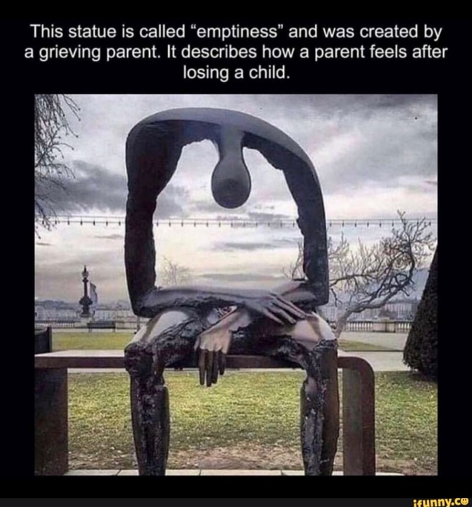
I suppose there’s a lot of metaphors or descriptions that one could have for grief. I saw one such description and commented about it in a video when I was in Kenya. It was a picture of a sculpture of a person who was bent over on a park bench. The entire midsection was empty. It was supposed to show the emptiness that a person feels when they lose a loved one and that this emptiness never goes away. I don’t think that’s a Christian idea. I’ve never had this feeling. How can someone who is a temple of the Holy Spirit feel emptiness? If that’s happening, then we have more problems than our loved one no longer being with us. Missing someone, grief, regret, other feelings – these things might never go away but emptiness is not one of those things. Since we have a deep heart, and God wants to live in this deep heart, how can we be empty?
I hope no one is offended by my words. Perhaps you felt empty when someone died. It’s just a word. But if it is a complete state of being, then your soul is in trouble. We must strive to fill our souls with God. If we are struggling, our souls cannot be empty, no matter what our emotional state is.
Three things that happened since +Daniel’s death that have very much filled my life even more than when he was alive. I mentioned the first one above. There’s a whole lot more prayer. Is not always easy prayer, and sometimes I have to scramble to get it done, but it has brought great blessings to me.

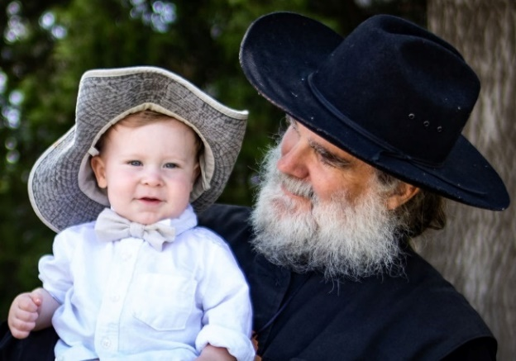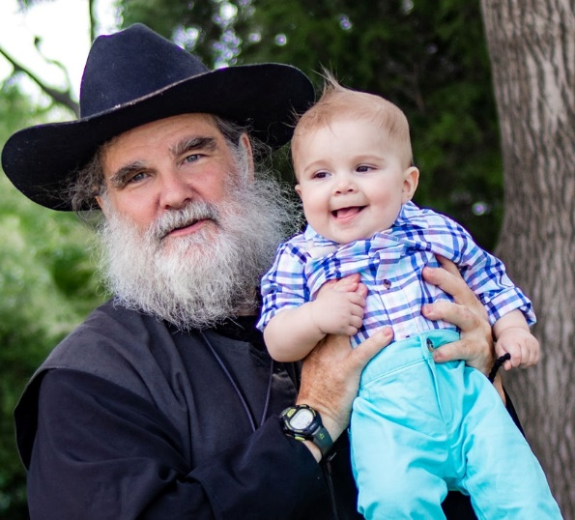
The other is that I lobbied especially with the mothers of my two youngest grandsons, to be able to take care of each one day a week. I’m not sure either one believed I was going to stick with it, but it’s now very clear that I’m here for the duration. Being part of the little boy’s life and seeing him grow up and change every day has been one of the most fulfilling things I’ve ever done. I take care of Noah, whom I call “monster man” and at this writing he is over 13 months old, and Owen (Axe man) who is over nine months old at this writing, and those boys are going to know me. I sing to them all the time, and they will know Orthodox Christian hymns. The future choir director might be mad at me because they might sing them completely correctly but they’re going to know them. My favorite thing to sing to them is the sequence of “Let God arise…” With the “Christ is risen…” troparion and subsequent verses that are the beginning of Paschal services. I learned how to do it on my own in a kind of West Virginia Appalachian melody that I heard in a podcast. My daughter Genevieve makes fun of me and says my style of singing is “seraphimskaya” (this made up Russian like word means “in the style of Seraphim”). All I know is that I love to sing it, and it generally makes them relax and go “night night”. Plus, my patron saint said “Christ is risen” every day, so I should be like him in the least some way.
Another favorite thing I do with the boys is make “monster movies” and “axman movies”. These are on some sort of theological topic, and I’m talking while I am holding them and they are being cute for the camera. I’m hoping that the “eye candy” makes some people watch that otherwise would not, and my intent is always the same with everything I write or make a video of, or when I talk to someone, or do catechesis; I want everybody to know the purpose of their life and either dedicate or rededicate themselves to it, so they would find paradise.
The third great event that happened since +Daniel’s death is that I went to Kenya, and in now very much involved in mission work in Africa. My wife and I plan to continue this. I was at St. Barnabas Orthodox orphanage and school for a month and she for two weeks, in January and February of this year. We fell in love with the school, Father Methodius and his family, and Kenya. Since that time, I’ve been involved in much fundraising for a dormitory, and have joined the board of Orthodox Africa.
So now, I think of my life in general as having four main ministries. Of course, parish life continues fast and furious, and we are growing a little bit and we are a very active parish. My prison ministry is way too busy for me to handle, and that continues, with me going to six prisons monthly, five of them twice a month. I plan to be involved in African missions for the rest of my life. And, my two youngest grandsons are going to know the faith, because I’m going to teach it to them. When my children were young, I was working full-time, and unfortunately my perspective was that of a young man, not an older one with more experience. Now I’m actually working harder than when I was working full-time, but my schedule has been arranged in such a way that I can have a full day with each one of those boys we have all heard about when somebody gets old, and I guess I’m almost to the point where I should say I am since I’ll be 61 this month, that a person enters into their “second childhood”. I would prefer to say that I’m entering into my “second parenthood”. I think I’m better equipped for this one.
This is a general letter to everyone, but especially to everybody who’s on “+Daniels list”. There are many hundreds of you who have promised to pray for +Daniel, and I promise to pray for you. You have, quite literally, my eternal gratitude. And while I am still breathing air, you have my promised daily prayers and commemoration at the Divine liturgy. Your prayers for myself and my wife Marina and for +Daniel have given me great comfort. I think it makes us connected in a spiritual way that we cannot discern but is nonetheless more real than an earthly connection.
I’m also connected to people that I’ve never met and never knew +Daniel or even knew about him. Experiencing the sudden death of a son is quite difficult. In my pastoral life I have known people that have experienced the sudden death of a loved one, not because of an accident or a sudden disease, but because of suicide. Also, some of you on +Daniels list and told me of your loved ones that have taken their own lives. Therefore “+Daniel’s list” also has many people, some whom I know and some whom I never knew, who committed suicide. I pray the prayer of St. Varus for them.I I do not make any claims about these prayers. There’s only one reason to pray anyway. It is because of love. God loves everyone, and the Scripture tells us that “all live to Him”. Since God does not stop loving anyone, no matter what they do, including die, we should not either, so if we love them when they are alive, we love them when they are dead in the flesh and we pray for them. That’s all I need. Other people need to have things defined in the bit more, but as you grow in the Orthodox faith and find out that even if you get the definition you don’t understand it, so it is better just to pray.
If you need anything from me that I am able to give, please contact me. If you pray for +Daniel, I will pray for you. If you are not on "+Daniel's list" yet are you have suffered another loss these past two years that you want to tell me about, please contact me.
This document: http://www.orthodox.net/+daniel/+daniel-anniversary-02-2019-06-11.docx & http://www.orthodox.net/+daniel/+daniel-anniversary-02-2019-06-11.pdf
Priest Seraphim Holland seraphim@orthodox.net 972-658-5433.

For an example, see: “Using the energy in grief”, a talk given at the St Herman Youth Conference, December, 2017, Kansas City http://www.orthodox.net/sermons/misc_2017+using-the-energy-in-grief+st-herman-youth-conference.doc http://www.orthodox.net/sermons/misc_2017+using-the-energy-in-grief+st-herman-youth-conference.pdf http://www.orthodox.net/sermons/misc_2017+using-the-energy-in-grief+st-herman-youth-conference.mp3
“Grief should not make you empty. It is part of the reason why I am in Kenya.” https://youtu.be/5bqvL8kOlmk
Lots of monster movies and axman movies and lots of other videos to choose from at http://youtube.com/orthodoxnet and the Videos section at: https://www.facebook.com/orthodoxnet/
https://orthodoxmissionkenya.org/
Mat 22:31-32 KJV “But as touching the resurrection of the dead, have ye not read that which was spoken unto you by God, saying, (32) I am the God of Abraham, and the God of Isaac, and the God of Jacob? God is not the God of the dead, but of the living."

